Gustavo Cestero

Dr. Bui

11/24/20

**Blender Activity 6: Texture Mapping**

Checkpoint 1:

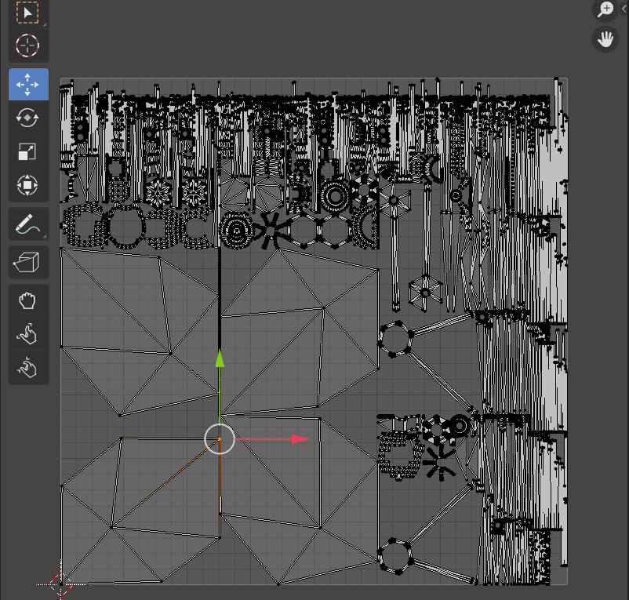

Checkpoint 2.1:

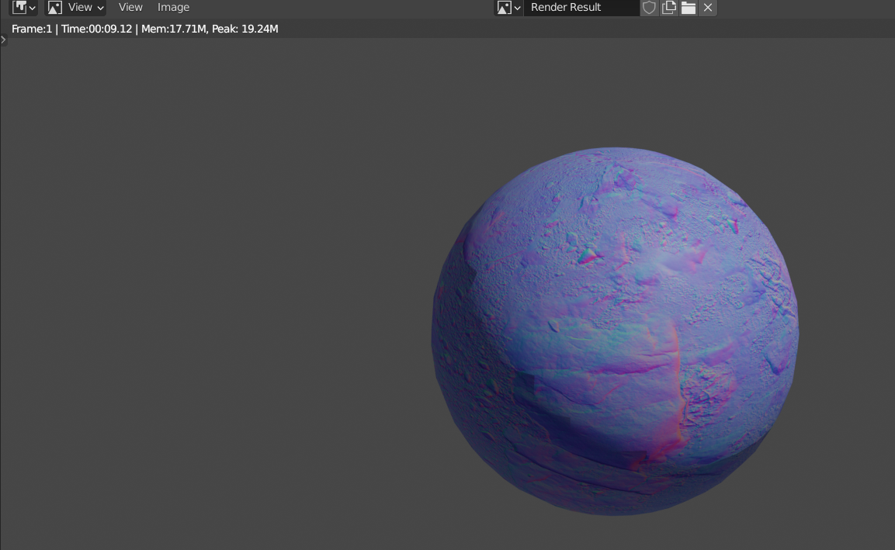

Checkpoint 2.2:

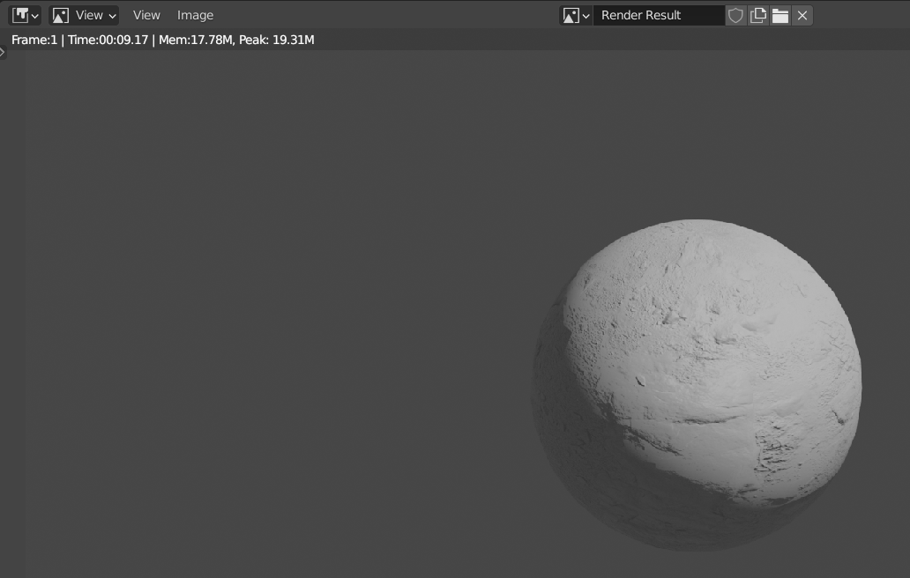

In this checkpoint, adding the effects of normal map diffused the color of my sphere with the rock texture.

Checkpoint 2.3:

